Firmware Upgrade on HP Proliant

Steps to Follow

1. Contact HP to get the link to ISO Images of the latest Firmware for all Gen 9 and Gen 10 Proliant Machines ( we mostly apply n-1 patches)
2. Upload those images on a shared drive and share it with the Team.
3. Take the dowtime of approx 3-4 from application owner of the server for the firmware upgrade.

Below are the images of FW upgrade.

1. Login to the server to get the console IP.

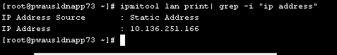

1. Open the ILO and Note down the System ROM and ILO Firmware Version.
2. From ILO, Click on Remote Console and Media select .NET OR and have a remote console open with the server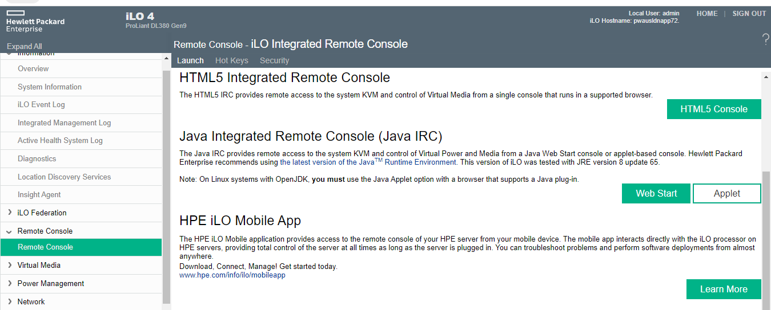
3. Click on Virtual Media and the upload the ISO image under Image File CD-ROM/DVD.

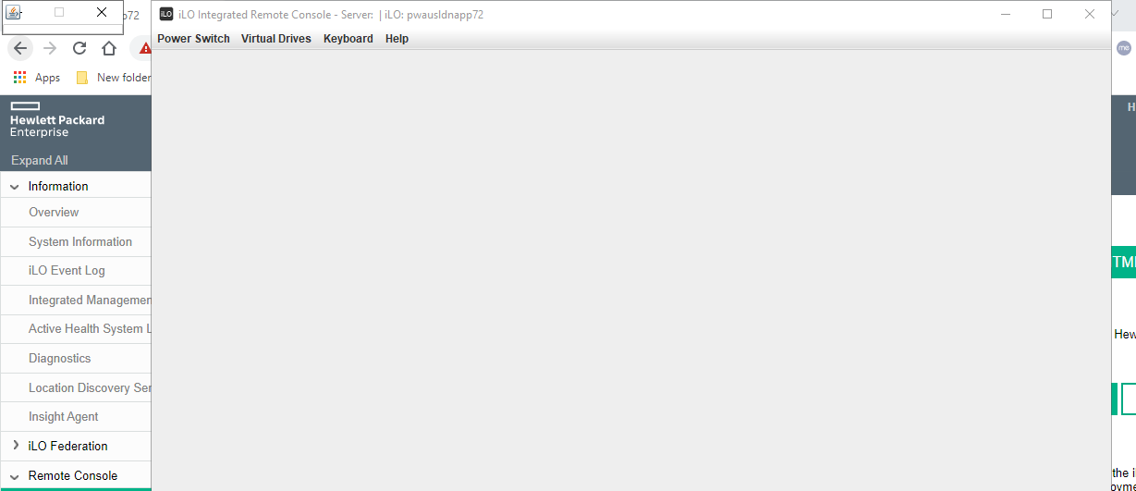

\\smb.waunas22f.hcscint.net\ltsdata\LANSUPP\Unix\HP\SPP-Nov-2021\Gen10-Gen10Plus\March2023

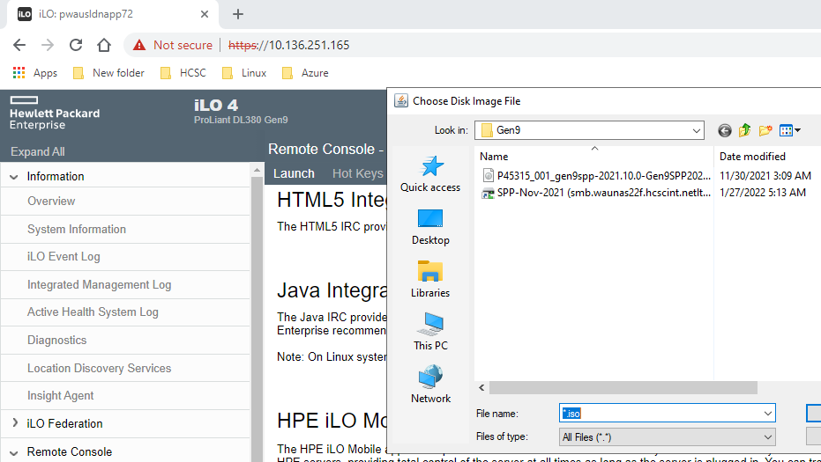

1. Click on Power Switch and Reset and System will boot from the Iso image and FW upgrade will start.

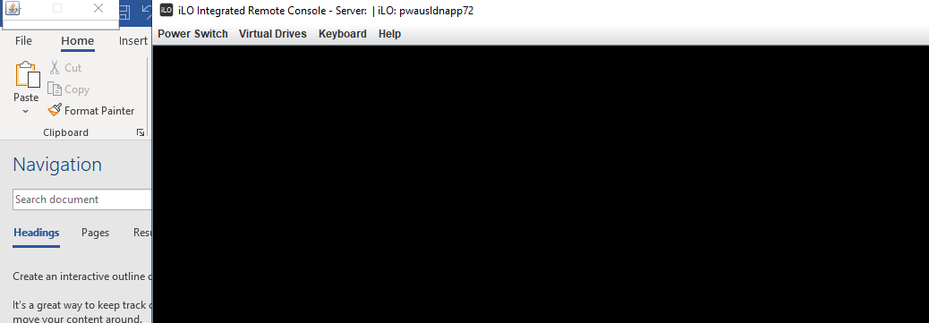

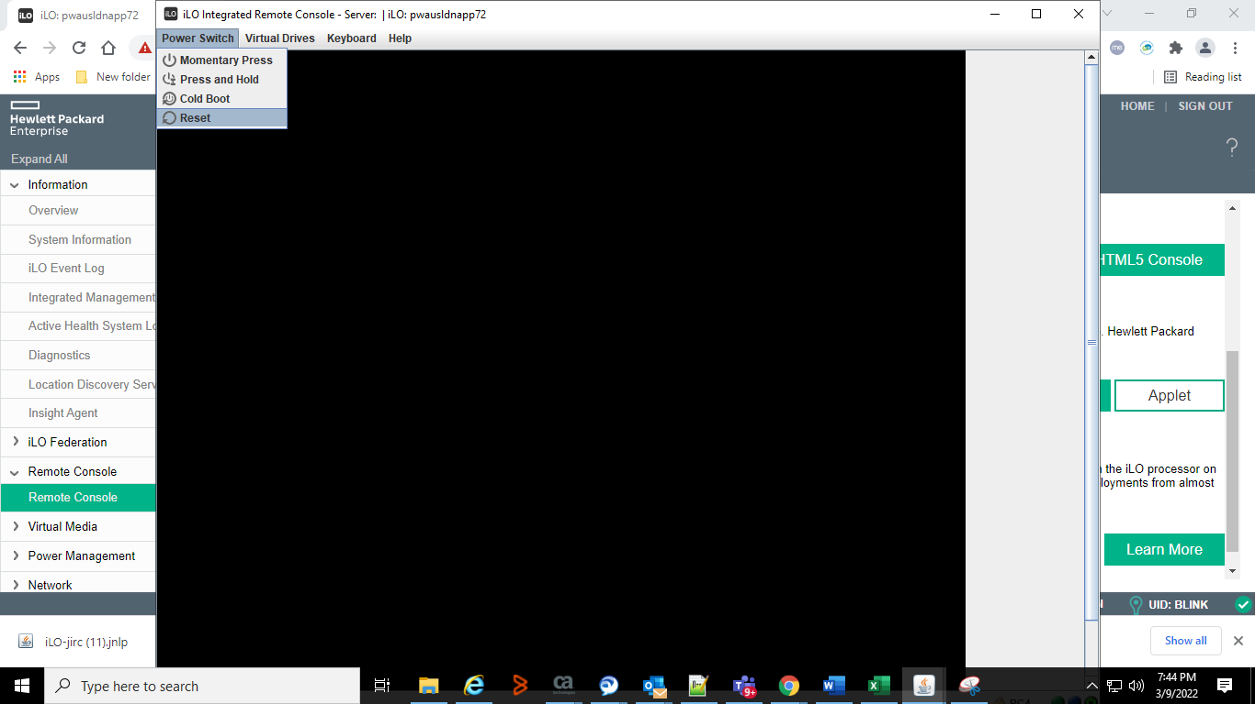

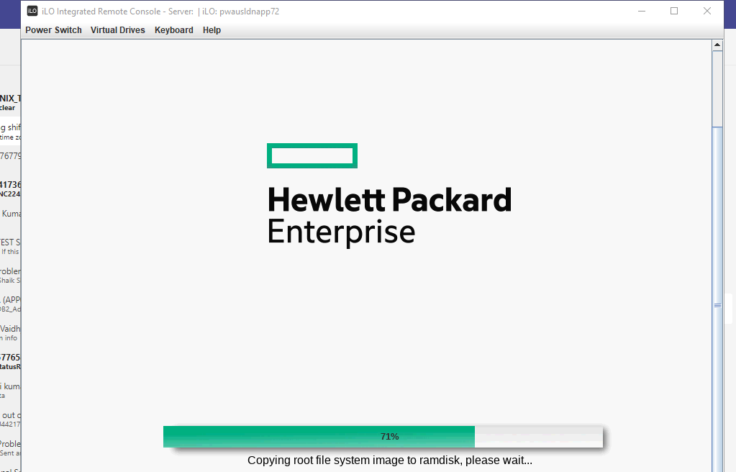

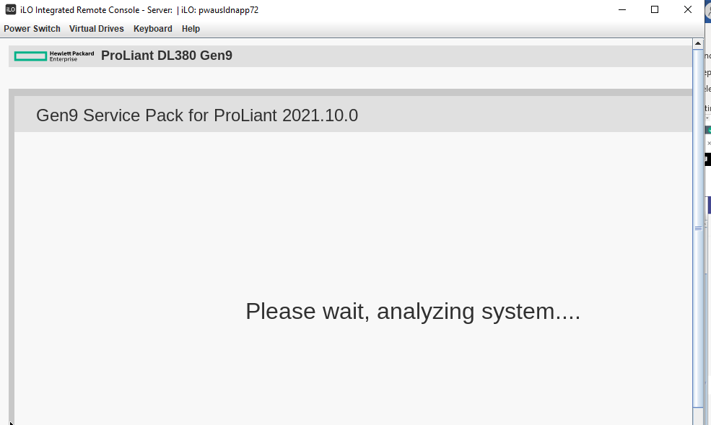

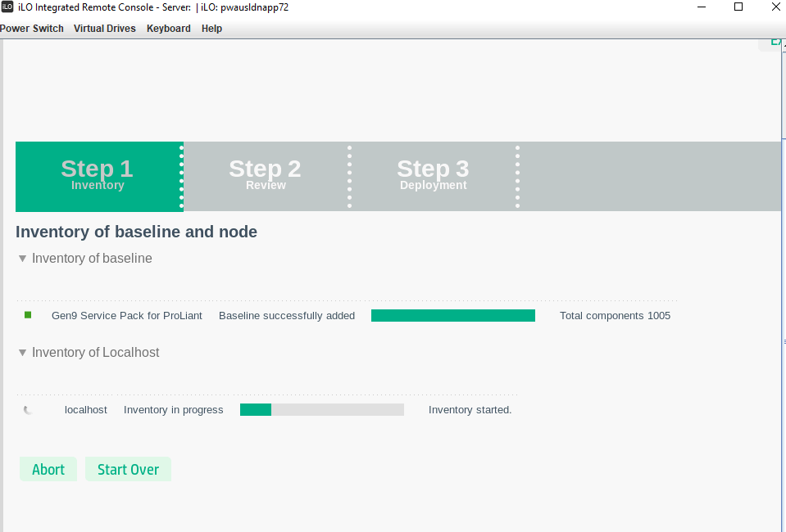

Once the update is done, the server will reboot..

Once the Upgrade is done, Verify the ILO version and System ROM.

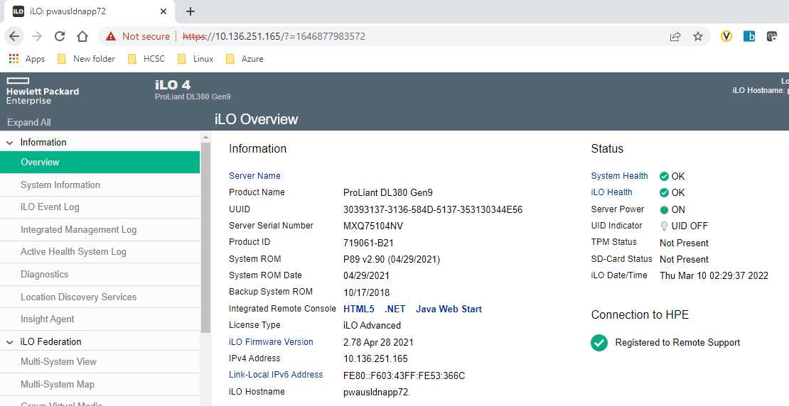

dmidecode -s firmware-revision

after update it should be 2.82 feb 2023